Retell SaaS Platform: System Design
Oct 12, 2026 · @Habibur Rhaman

Summary
We can turn the existing Retell dashboard into a multi-tenant SaaS in roughly nine weeks by keeping the current stack and adding an admin panel, a usage record fed by Retell webhooks, and one limit guard that blocks a sub-account the moment it crosses a limit.
- Kept: Next.js, TypeScript, Prisma, PostgreSQL and every current feature.
- Added: admin panel, signed sub-account links, usage ledger, admin switches to suspend a sub-account or turn off any feature, limits with automatic locks and "limit reached" messages, and tests for every route, function and component.
- Two blockers in today's code: nobody is logged in (a location ID in the URL is the only key) and usage is not recorded anywhere. Both are fixed first.
- Decisions needed: questions 2, 4 and 6 under Open questions change the design most. The rest have a working assumption.

What exists today
The current app is a working single-purpose dashboard: one sub-account (a "location") manages its own Retell agents and knowledge bases through one shared Retell API key. It has no login, no limits and no admin side.
Area | Current state
Stack | Next.js 16 (App Router), React 19, TypeScript, Tailwind 4, React Query, Zod, Prisma 6 on PostgreSQL
Tenancy | One Location row per sub-account, plus LocationAgent and LocationKnowledgeBase mapping tables. The location ID is read from the URL (/retell/[locationId]/...)
Features | Voice and text agents (single prompt or conversation flow, templates, versions, publish), knowledge bases, test call, test chat, AI-simulated chats, analytics, account settings
Naming | New agents and knowledge bases are saved as {name} - {location name}
Backend | 24 API route files under /api/retell/* and /api/locations/*. Most call Retell directly through one 550-line retell-api.ts
Embedding | Pages are allowed to be framed by any site. The link template {{location.id}} in the code suggests it is opened inside a CRM such as GoHighLevel (inferred, not stated)
Tests | None. No test runner is installed
Health | ESLint: 0 errors, 2 warnings. Type-check could not be completed in my sandbox because Prisma's engine download was blocked; every error it printed traces to the missing generated client

Requirements as understood
We become the operator of a SaaS: we hold one paid Retell account, and every sub-account is a customer tenant whose agents live inside it. We control what each tenant may use. "etc." in the brief means more limit types will follow, so limits must be data, not hard-coded.
# | Requirement | Status in current code
1 | All sub-accounts run on our one paid Retell account | Done (one shared API key)
2 | Admin panel for us only | New
3 | Register a new sub-account from the panel and get its URL | New. Today a location row appears the first time someone opens a URL
4 | Admin sees every sub-account and the agents each created; agent names carry the sub-account name | Partly. The {name} - {location} rule exists on create only
5 | Per-sub-account limits: agents created, minutes of use, minutes talked, number of calls, more later | New
6 | When a limit is crossed, disable that feature for that sub-account, block the action, show a "limit reached" message | New
7 | Every API, function and component has tests | New. There are none today
8 | Separate modules so the product scales | Partial. lib/ is flat and routes hold business logic
9 | Explain the design to the boss | This document
10 | Admin can suspend a whole sub-account or switch off any single feature. Everything else keeps working while it is switched on and within its limit | New

Feature catalog and access control
Every capability a sub-account can use is a named feature with its own admin switch. Some features also carry a limit. The catalog below is what the current dashboard offers, grouped as the sub-account sees it.
Group | Feature key | What the sub-account can do | Limited by
Agents | agents.create_voice | Create voice agents, blank or from a template, single prompt or flow | Number of agents
Agents | agents.create_text | Create text (chat) agents | Number of agents
Agents | agents.edit | Edit prompt, voice, language, pronunciation and post-call analysis | Switch only
Agents | agents.delete | Delete its own agents | Switch only
Agents | agents.flow_editor | Build and edit conversation flows | Switch only
Agents | agents.functions | Add custom functions and tools to an agent | Switch only
Agents | agents.versions | See version history, publish or restore a version | Switch only
Knowledge | kb.manage | Create knowledge bases, add or remove sources | Number of knowledge bases
Testing | test.call | Start a web test call to an agent | Call minutes, calls
Testing | test.chat | Text test chat with an agent | Switch only for now
Testing | test.simulation | AI-simulated chat against an agent | Switch only for now
Live calls | calls.inbound | Agents answer inbound calls | Call minutes, calls, concurrent calls
Live calls | calls.outbound | Agents place outbound calls | Call minutes, calls, concurrent calls
Insight | analytics.view | Call, cost, latency and sentiment dashboards | Switch only
Insight | numbers.view | See the phone numbers assigned to it (planned, see open question 5) | Switch only
Live-call features are enforced at Retell, not in the screens: inbound by the inbound webhook, outbound by removing the agent from the number. "Switch only" means no usage limit exists yet, and a metric can be added later without changing the catalog.
Three switches decide access. A feature works only when all three are open:
- Account status is active. The admin can suspend a whole sub-account. Every feature stops, including live calls. Agents and data are kept.
- The feature switch is on. The admin turns one feature off for one sub-account. It stays off until the admin turns it on again.
- The limit is not reached. Automatic. It reopens when the admin raises the limit or the monthly period rolls over.
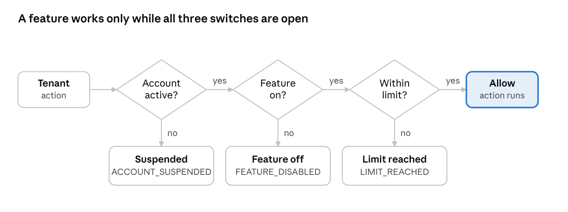
access decision · 3 switches, 3 block reasons
When all three are open the sub-account uses the feature normally. When one is closed, the sub-account sees its own message, and the checks run in this order:
Closed switch | Error code | Message the sub-account sees | Who reopens it
Account suspended | ACCOUNT_SUSPENDED | "This account is suspended. Contact support." | Admin
Feature off | FEATURE_DISABLED | "This feature is not enabled for your account." plus the admin's reason | Admin
Limit reached | LIMIT_REACHED | "You have used 500 of 500 minutes this month. Contact support to raise your limit." | Admin raises the limit, or the period rolls over
The three states are stored separately, so reopening one never reopens another. Raising a limit does not undo an admin's decision to switch a feature off.

Problems found in the current code
The code is tidy and linted, but it was built as a trusted single-customer tool. Two findings block the SaaS outright: nobody is authenticated, and usage is not measured.
Severity | Finding | Where | Fix
Critical | No authentication. The locationId in the URL, query or body is the only key, so anyone who knows another sub-account's ID can read, edit or delete its agents | Every route under /api/retell/* | Signed sub-account token plus admin login. Tenant ID comes from the session, never from the request
Critical | Unprotected global routes. DELETE /agents/cleanup wipes every agent mapping. /llm/[llmId] reads and edits any prompt in the Retell account. /agents/available lists every unassigned agent and /agents/import lets any location claim one | agents/cleanup, llm/[llmId], agents/available, agents/import | Remove cleanup. Move import to admin only. Check LLM ownership through the agent mapping
High | Location name is editable by anyone via ?locationName= or PUT /api/locations/[id]. Renames do not reach existing agents, and PATCH on an agent name does not re-apply the - {location} suffix | location-name-sync.tsx, locations/[locationId], agents/[agentId] | Name is owned by admin. One naming service applies the rule on create, rename and sync
High | Usage is never measured. Analytics reads up to 10,000 calls live from Retell on every page view and totals them in memory. Test calls, test chats and simulations spend credits with no record | analytics/route.ts, web-call, chat, simulate | Record usage from Retell webhooks into our database. Limits read from there
High | Settings are forwarded to Retell unfiltered, so a tenant can choose the most expensive model, remove call-duration caps or change webhook URLs | agents/[agentId] PATCH, llm/[llmId] PATCH | Allow-list of editable fields and models per plan
Medium | Every request lists all agents in the whole Retell account, then filters by tenant. Cost and rate-limit pressure grow with every tenant added | retell-api.ts listAllAgents, used by agents, create, analytics | Read from our database; sync from Retell by webhook and a scheduled job
Medium | Check-then-create races: two simultaneous creates can both pass the duplicate-name check, and would both pass an agent-count limit | agent-name-check.ts, create routes | Database unique constraint, plus an atomic reserve step for counted limits
Medium | The schema targets PostgreSQL, yet a SQLite dev.db ships in the zip and there is no prisma/migrations folder, so schema changes are not versioned | prisma/ | Adopt Prisma migrations before adding the new tables
Low | Any website may embed the app (frame-ancestors *) | next.config.ts | Allow only the CRM's domains
Low | Business logic sits inside route handlers (the create route is 160 lines), which makes unit tests hard | agents/create/route.ts and others | Thin routes calling services, as in the module layout below

Open questions and assumptions
Nine points need a decision. The design below works with the assumption shown, so a different answer changes details, not the structure.
# | Question | Why it matters | Assumption used
1 | How do sub-accounts open the app: inside the CRM as today, or their own login page? | Decides how we prove who the caller is | Still opened from the CRM. The admin panel mints a signed link per sub-account
2 | What exactly is "minutes used" versus "minutes talked"? Retell bills per call minute and does not split talk time by speaker | Decides which limits we can really enforce | Both mean billed call minutes. Calls made is a separate count
3 | Do limits reset monthly, never, or by top-up? | Decides how counters roll over | Monthly reset, and admin can add a top-up
4 | Who starts calls? Inbound on Retell numbers, outbound from the CRM straight to Retell, or from our app? | We can refuse inbound calls ourselves; outbound started outside our app cannot be intercepted | Inbound is blocked at the Retell inbound webhook. Outbound is blocked by removing the agent from the number
5 | Are phone numbers in scope? The current app has no number management | We need to know which number belongs to which sub-account | Numbers are assigned to sub-accounts by admin, view only for tenants
6 | At the limit, do we only block the dashboard or also stop live calls? | Blocking only the dashboard does not stop spend | Both. Dashboard actions are blocked and new calls are refused
7 | If a call is running when the limit is hit, do we cut it? | Cutting mid-call is bad for the caller | No. It finishes. Each agent gets a maximum call length to cap the overshoot
8 | One admin or a team with roles? | Decides the admin auth model | Small team, two roles: owner and support (read only)
9 | Will we charge sub-accounts per minute later? | The usage record should carry cost from day one | Out of scope now. We store the cost per call so billing can be added

Target architecture
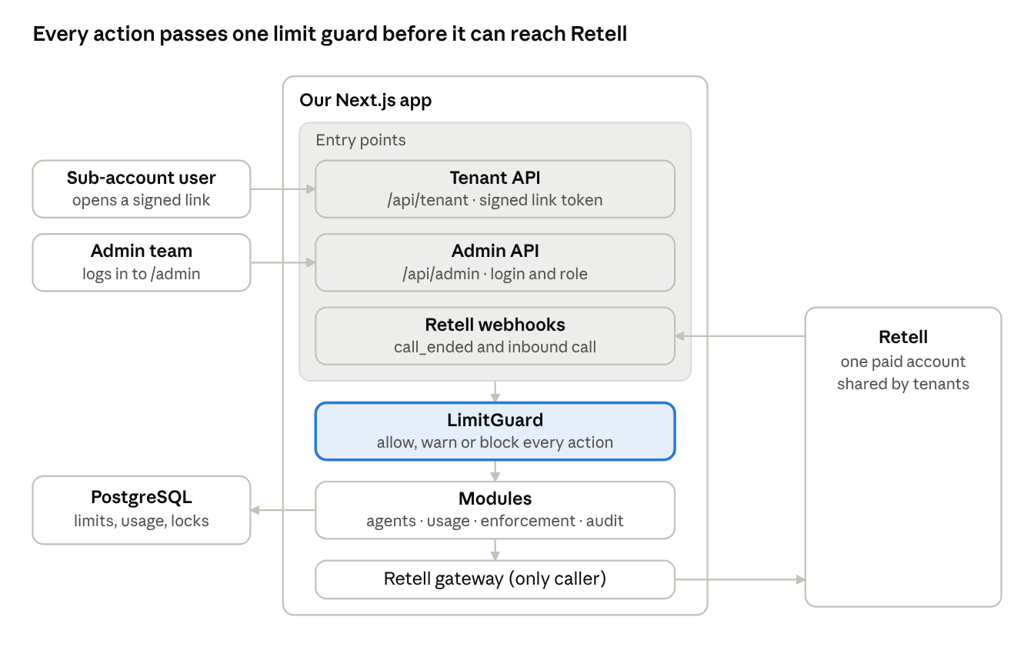
target architecture · one app, one guard, one gateway
Users, admins and Retell webhooks enter through three API groups. Every call passes the LimitGuard and then the modules, and only the Retell gateway talks to Retell. The database holds all tenant, limit and usage data.

Data model
Ten tables carry the new product. The existing Location, LocationAgent and LocationKnowledgeBase tables are renamed and extended, so current data migrates in place.
Table | Purpose | Key fields
tenants (was locations) | One row per sub-account | id, crm_location_id (unique), name, status (active, suspended), retell_workspace (reserved for sharding)
access_links | Signed URL tokens a sub-account uses to open the app | tenant_id, token_hash, expires_at, revoked_at
admin_users | People who use the admin panel | email, role (owner, support), password_hash
agents (was location_agents) | Which Retell agent belongs to which tenant | tenant_id, retell_agent_id (unique), name, channel, status
knowledge_bases | Same mapping for knowledge bases | tenant_id, retell_kb_id (unique), name
limit_policies | One limit per tenant per metric | tenant_id, metric, period (monthly, lifetime), limit_value, warn_at_pct, mode (hard, soft). Unique on tenant_id + metric
usage_events | Append-only record of every call or chat, written from Retell webhooks | call_id (unique), tenant_id, agent_id, kind, duration_sec, cost_cents, started_at
usage_counters | Running total per tenant, metric and period, updated in the same transaction as the event | tenant_id, metric, period_start, value
feature_locks | What a limit has switched off for a tenant right now, and why | tenant_id, feature, reason, locked_at, cleared_at, saved_bindings
audit_log | Who changed what | actor, action, target, before, after, at
tenant_features | The admin's on/off switch per tenant and feature, with the reason the tenant sees | tenant_id, feature_key, enabled, reason, changed_by, changed_at
metric is an enum we can extend: agents, knowledge bases, call minutes, calls, concurrent calls. Adding a new limit type means one enum value, one counter rule and one guard call. No new table.

Limits and enforcement
One LimitGuard decides every "may this tenant do this?" question, and checks account status, the admin's feature switch and the limit, in that order. Usage from Retell feeds the limit check. Two kinds of limit need two mechanisms.
Counted resources (agents, knowledge bases, numbers) are checked at the moment of creation. The count and the insert run in one database transaction holding a lock on the tenant's limit row, so two simultaneous requests cannot both slip past a limit of 1.
Consumed usage (call minutes, calls) is only known after a call ends. Retell sends a call_ended webhook, signed in the x-retell-signature header. It retries up to three times, so duplicates arrive and the handler must be idempotent. Our handler does five things, in order:
- Verify the signature against the raw body, return 2xx fast, and park the event in an inbox table.
- Map agent_id to a tenant and insert a usage_events row, unique on call_id, so a retry counts once.
- Increment the tenant's counter in the same transaction.
- At the warning percentage, flag the tenant. At the limit, create a feature_locks row.
- Run the disable actions for that metric (next table) and write the audit log.
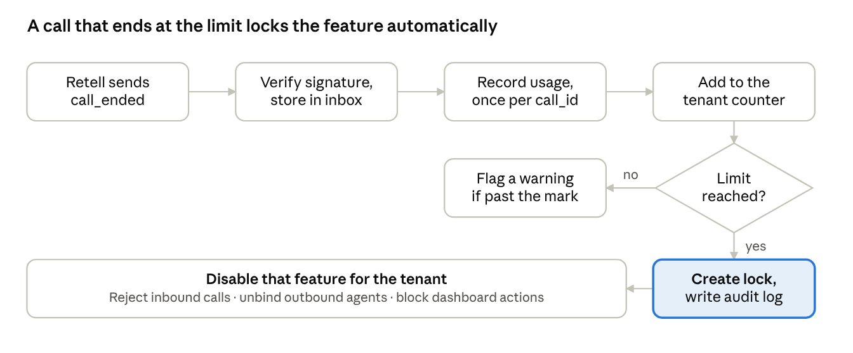
usage to lock flow · 5 steps, 1 decision
The whole flow runs inside the webhook handler, so the lock is created as soon as the call that crosses the limit is recorded. What "disable" means for each metric is in the table below.
Limit reached | What gets disabled | How
Agents or knowledge bases | Creating more | The create API returns LIMIT_REACHED; the button is disabled with a message
Call minutes or calls | Test calls, test chats, simulations | Same guard on those endpoints
Call minutes or calls | New inbound calls | Retell's inbound call webhook accepts { "reject": true }, which hangs up before any agent starts and creates no call
Call minutes or calls | New outbound calls started outside our app | We remove the tenant's agents from the number's outbound list and save the old binding in saved_bindings. The Retell update phone number API lists these fields as nullable, but does not state what null does, so this needs a one-day test before we rely on it
Agents are never deleted. When the admin raises a limit, or the monthly period rolls over, a scheduled job clears the lock and restores the saved bindings.
What the tenant sees. Blocked APIs return HTTP 403 with { code: "LIMIT_REACHED", metric, used, limit, message }. One useEntitlements() hook gives every component { enabled, used, limit } per feature, so buttons disable themselves and a banner reads "You have used 500 of 500 minutes this month. Contact support to raise your limit."
Safety nets.
- A reconciliation job lists recent calls from Retell on a schedule and fills any gap left by a lost webhook.
- A running call is allowed to finish. To cap the overshoot, each agent gets a maximum call length no longer than the minutes the tenant has left.
- If our database is down, inbound calls are let through and an alert fires (fail open: we do not drop a customer's caller). Dashboard create actions fail closed. The boss should confirm this choice.

Admin panel scope
The admin panel lives under /admin, behind its own login and its own API prefix, so a tenant token can never reach it. Version 1 has five screens.
Screen | What the admin can do
Overview | See every sub-account with agents used, minutes used and limit, calls, and a warning or locked badge. Sort by closest to limit
Register sub-account | Enter the name and CRM location ID, set starting limits, and get the sub-account's URL to paste into the CRM. The name is stored once here and becomes the suffix of every agent name
Sub-account detail: Agents | List every agent the sub-account created, with channel, creator and creation date. A naming check flags any agent whose name does not end with - {sub-account name}
Sub-account detail: Limits and usage | Edit each limit, add a top-up, lock or unlock a feature by hand, and see usage charts by day
Sub-account detail: Access | Show, rotate or revoke the URL token. Suspend or reactivate the whole sub-account. Every change is written to the audit log
Sub-account detail: Features | Switch any feature on or off for this sub-account and write the reason the sub-account will see. A switched-off feature stays off until the admin turns it on
What the sub-account sees stays as it is today, minus the controls that move to admin: it cannot rename itself or import agents, and it gets the usage meter and limit messages.

Modular code structure
We build a modular monolith: one deployable app, split into domain modules with enforced boundaries. It is the cheapest structure that scales, because any module can later become its own service without a rewrite.
src/
app/ routing only: pages and thin route handlers
(tenant)/retell/[locationId]/...
admin/...
api/tenant/... session-scoped endpoints
api/admin/... admin-only endpoints
api/webhooks/retell/ call_ended, inbound call
modules/
retell/ the ONLY code that calls Retell (client, types, fake for tests)
tenants/ register, status, naming rule
auth/ signed links, admin login, session
agents/ create, update, delete, versions, templates
knowledge-bases/
limits/ policies, LimitGuard, error contract
usage/ ledger, counters, reconciliation
enforcement/ locks, unlock, phone-number bindings
analytics/ reads usage tables, not Retell
audit/
shared/ config (env checked by Zod), errors, logger, UI kit
Each module has the same inside: service.ts (business rules), repository.ts (database), schemas.ts (Zod input checks), index.ts (its public surface) and __tests__/.
Three rules keep it from rotting:
- A route handler does four things only: authenticate, validate, call one service, return the result.
- Modules call each other only through index.ts. A lint rule (no-restricted-imports) fails the build on anything else.
- Every repository function takes a tenantId. There is no query that can return another tenant's rows by accident.
The current code moves in step by step: retell-api.ts becomes modules/retell, the pure helpers (naming.ts, location-matching.ts, validators.ts) move into their modules unchanged, and the React components stay where they are.

Testing strategy
"Every API, function and component has a test" becomes a rule the build enforces, not a habit. Retell is replaced by a fake in every test, so tests are fast and cost no call minutes.
Layer | Tool | What it proves | Example
Unit | Vitest | Pure functions behave on edge cases | Naming rule, name matching, phone and URL validators, period windows, limit arithmetic
Service and database | Vitest on a real PostgreSQL in Docker, Retell fake | Business rules and transactions | Limit of 1 and 5 parallel creates: exactly one succeeds. The same call_id sent twice counts once. Lock clears when the limit is raised
API | Vitest calling route handlers | Each route's contract | No token gives 401. Another tenant's agent gives 403. Bad input gives 400. Over the limit gives 403 LIMIT_REACHED. Happy path gives 2xx
Component | Vitest and React Testing Library | Each UI state renders | Loading, error, empty, and limit reached with the create button disabled and the message shown
End to end | Playwright | The whole story works in a browser | Admin registers a sub-account, opens its URL, creates agents until the limit, sees the message, admin raises the limit, create works again
Webhook | Vitest with saved Retell payloads | Our handler matches Retell's real format | Signature check, duplicate delivery, unknown agent
Two guards make the rule stick:
- A route-matrix test lists every route.ts file and fails if one has no test file or is not wrapped by the auth helper. A new unprotected route cannot be merged.
- CI (lint, type-check, all test layers) blocks every pull request. Coverage gates are strict on the money-and-security modules (limits, usage, enforcement, auth) and relaxed elsewhere.
The first tests we write are for the pure helpers already in the code, because they are the cheapest and they protect the migration.

Scalability and tech stack
The current stack stays. We add only what the new requirements need, so nothing is thrown away.
Layer | Choice | Status | Why
App | Next.js 16, React 19, TypeScript, Tailwind 4 | Keep | Already built and working
Data access | Prisma 6 with migrations | Keep, add migrations | Typed queries, versioned schema
Database | PostgreSQL | Keep | Transactions and row locks are what the limit guard relies on
Validation | Zod | Keep | Used on every route and for environment variables
Client data | React Query | Keep | Powers the useEntitlements() hook
Tenant auth | Signed link tokens (JWT, jose) | New | Fits the CRM-embedded model without a second login
Admin auth | Auth.js with roles | New | Standard, well tested
Background work | Webhook inbox table plus a scheduled route for reconcile and period rollover | New | No extra infrastructure at first. Move to a queue (Inngest or BullMQ) when volume needs it
Tests | Vitest, React Testing Library, Playwright, Docker PostgreSQL | New | See testing strategy
Monitoring | Sentry, structured logs, an alert on webhook delay | New | A missed webhook means a missed limit
How it grows:
- Stateless app servers. Add instances freely. All state is in PostgreSQL.
- Database first. Pages read agents and usage from our tables. Retell is called only to change things, and by the sync jobs. Cost no longer grows with every tenant's agents.
- Append-only usage ledger with an index on tenant and time. Partition by month once it reaches tens of millions of rows.
- Retell client with a rate limiter (token bucket, retry with backoff), because all tenants share one API key and one Retell rate limit.
- One shared Retell account is the real ceiling: its concurrent-call and rate limits are shared by all tenants. The tenants.retell_workspace column is reserved so tenants can later be spread over several Retell workspaces without changing code.
- Isolation by construction: tenant-scoped repositories now, PostgreSQL row-level security as an optional second lock later.

Phased roadmap
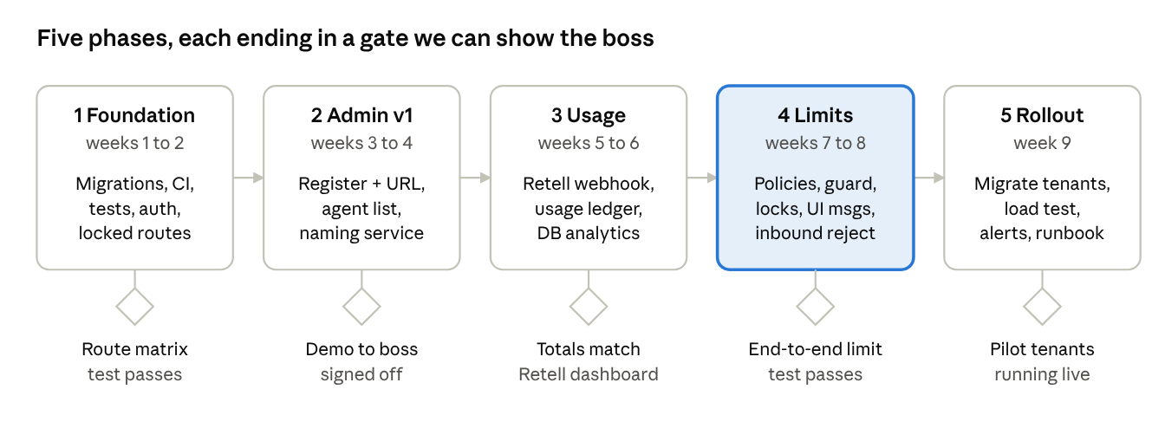
phased roadmap · 5 phases, 5 gates, not to scale
Durations are rough, for one or two developers, and will be firmed up after Phase 1. The admin switches (suspend a sub-account, turn a feature off) are built in Phase 2 and enforced by the same guard in Phase 4. Security comes first because nothing else is safe to demo without it. The one-day test of how Retell treats an empty outbound binding runs at the start of Phase 3, so Phase 4 does not depend on a guess.

